Guidance on Disabled Evacuation Procedures, Fire Refuge Areas and Evacuation methods

Introduction

The responsibility for the evacuation of people from a building rests with the Club. This Safety Note explains the general principles that underpin the procedures for the evacuation of disabled people from Club buildings.

Evacuation Arrangements
If a person is unable to evacuate out of a building, or they may be slow to do so, due to a physical or mental disability, there are a number of systems available in several Club buildings to assist with evacuation. These include:
  - Fire refuge areas
  - Evacuation lifts
  - Evacuation chairs
  - Evacuation Mattress

The refuge areas should be in a 30 minute fire protected area, (protected stairs, lobby, or corridor). This gives any person needing to use the refuge a minimum of 30 minutes protection from the effects of smoke and fire.
If the person in the refuge does not have a buddy, to reduce anxiety to a person in this area a fire warden will return to the refuge area to stay with the person until they informed that they will be evacuated, or it is safe to return to your work area.

Only in the event of a fire will a person be assisted from the refuge to the assembly point by means of the evacuation chair, evacuation lift, evacuation mattress, or with assistance down the stairs.

Fire routine for disabled staff and visitors
A plan of action for a member of staff or visitor with a disability should be completed at the earliest opportunity when the disabled person joins the Club or registers as attending if a visitor. The Line manager (for new, and existing staff) will inform the Fire Safety Advisor who will then conduct a Personal Emergency Evacuation Plan should the disabled person want one. Where a disabled person requires assistance to evacuate, as a general rule they and a “buddy” should go to a fire refuge area and remain there. Fire Wardens should check refuge areas as they ‘sweep’ the building and evacuate. Occupants of refuge areas should tell the Fire Warden that they need assistance, the fire warden will notify the Evacuation Officer at the assembly point. The refuge Emergency Voice Communication equipment can be used by the person or buddy in the
refuge to keep in contact with the Control room or Reception. The person in the refuge must not be left by themselves. They can have a buddy to stay with them, if not the fire warden should return to the person in the refuge area.

The evacuation procedure from the refuge to an ultimate place of safety will depend on the confirmation of a fire or other emergency situation.

Fire Refuge Areas

What is a Fire Refuge Area?
A refuge is a location where people who need help to evacuate can wait for assistance.
Whilst awaiting this assistance, they need to be protected so that they are reasonably safe from the effects of a fire. Club fire refuges are therefore generally protected for a period of time, to enable the evacuation to be completed without placing the person(s) needing assistance, or those providing assistance, at unacceptable risk.
Although Refuge Areas are designed primarily for wheelchair users, they may also be used by other disabled people who may require assistance during an emergency evacuation e.g. people with reduced mobility, visual or hearing impairment, or mental disability.
Refuges should only ever be considered as temporary waiting areas. Refuges should not be used as a place to leave disabled people to await rescue by the fire service.

Location of Fire Refuge Areas
Normally the refuge is located within a fire protected staircase or a protected enclosure that will offer a minimum of 30 minutes fire and smoke resistance. A protected enclosure may be a fire protected corridor or in some cases a section of the building that is divided with fire resisting construction such as can be found in the main Club building.

How do I recognise a Refuge?
Doors leading to the refuge enclosure are identified by a green and white "Wheelchair user" pictogram. These signs are normally located next to the standard "Fire Exit" or incorporated into the signs with a directional arrow. The refuge area itself is signed with the green and white "Wheelchair user" pictogram and the words "Refuge Point" “Keep Clear”.
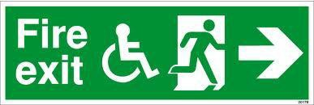
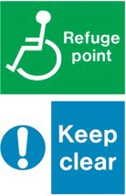
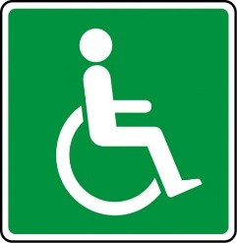

Refuge communications
Club refuges are equipped with an emergency two way voice communication (EVC) system to enable occupants of a refuge to alert other people that they need assistance, and for them to be reassured that this help will be forthcoming.
Typically, the voice communication systems in use are the ‘Complus’ system for refuges without an evacuation lift next to the refuge, and the ‘Windcrest’ system where evacuation lifts are installed. Both systems are linked to a ‘master control point’ within the main building Control Room and Reception.

Examples are shown below.

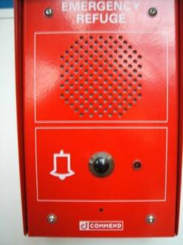
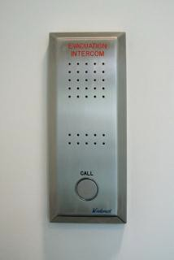

It is essential that there is good communication between those organising the evacuation of the building and all refuges. The persons controlling the evacuation need to ascertain in respect of each and every refuge:
- How many people require evacuation assistance
- If an evacuation chair or mattress is required
- To confirm the refuge in which they are located.
They should be kept informed of progress towards helping them to evacuate through the communication panel and/or fire warden/buddy.

Use of passenger lifts for fire evacuation
A passenger lift cannot be used for fire evacuation purposes owing to the risk of power failure and being affected by fire or smoke. However specially protected evacuation lifts can be used for the evacuation of disabled people only. These lifts are operated under the direction and control of the fire evacuation officer, security officer, or trained staff.

An evacuation lift, where provided, should always be available for evacuation purposes. Wherever practicable it needs to be a lift used routinely as a passenger lift and not one used solely for evacuation or as a lift for transporting goods.

Evacuation Chair

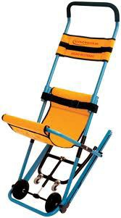
A Disabled Evacuation Chair is a specially designed folding chair that can be used to transport a disabled person down a building fire evacuation staircase.

Note: evacuation chairs are NOT suitable for use on circular stairs or on some external escape stairs.

Evacuation Mattress

Evacuation Mattresses are available in certain buildings.

The mattress is specially designed to lay someone upon and to be securely strapped into to safely move through a building and down staircases.

Evacuation mattress are more suitable for many people, especially people you may be having severe difficulties moving, or seizures.

Who can use the evacuation equipment methods?

Any trained person can use these methods. Any person unsure about their ability to use these methods should seek medical advice before volunteering for training.

Staff who are designated to assist people during an evacuation must be properly trained in how to use these methods, and the general fire safety procedures to be followed.
Disability equality and awareness training will also improve the confidence and effectiveness of staff in managing an evacuation.

Practise using the evacuation methods.

It is vital that people who have been trained in the use of evacuation methods have the opportunity to practice. All people trained to use these methods should get the opportunity to practice at least twice a year. Evacuation by using staircase

Many disabled people are able to descend (or ascend) a staircase, possibly with assistance. Others might need to transfer to an evacuation chair. The method of evacuation should be discussed with the individuals concerned and if needed incorporated in a PEEP if special assistance is required.

People with sight or cognitive impairments will probably be able to walk up and down stairs but may need direction and assistance. Fire routine for disabled visitors

A disabled visitor should be met by the person with whom they have an appointment, or a nominate deputy. Where possible arrangements should be made that the visitor and associated activities are carried out on the ground floor. In the event of an emergency evacuation, the host or deputy should escort the visitor to the assembly point or refuge area and remain with them. The routine is otherwise the same as for disabled staff i.e. remain in the refuge, ensure a message is relayed to the Evacuation Officer at the Assembly Point. The refuge Emergency Voice Communications equipment can be used to keep in contact with the Control room and Reception should this be necessary. Practice evacuations

A test evacuation should be carried out at least once a year (preferably twice a year). Maintenance Team members should provide advance warning of a fire drill – this will ensure the disabled person becomes practised in the fire routine and is fully involved in the procedures.
However where the evacuation procedure could involve use of an evacuation chair, or mattress, any risk to the person should be considered, and it may be preferable to conduct practice evacuations with volunteers, acting as a person requiring assistance.
Repeated evacuations such as false alarms can pose risks, therefore it is important as mentioned earlier that an evacuation from the refuge should only be carried out in the event of a confirmed fire or other emergency incident that requires an evacuation.
Providing an accessible means of escape solution should be an integral part of the fire safety management process. Particular attention should be paid to the needs of disabled people, and fire evacuation must not rely on assistance by the Berkshire Fire and Rescue Service. It cannot be assumed that facilities provided in a building to make it accessible, such as passenger lifts, will be usable in a fire evacuation, or that all mobility impaired people can use evacuation chairs.

This needs to be considered at the design stage when it is easier to incorporate accessible features which will make evacuation management more effective, and which will help to preserve the dignity of disabled people. To this end, fire evacuation lifts are the Club’s preferred means of evacuation where practicable.

