CAPACITY CALCULATIONS

READING FOOTBALL CLUB STADIUM
JUNCTION 11, M4
READING
RG2 0FL
Date | 20/05/25
Version | V11
Review Date | June 2026
Written by | David Parker
Reviewed by | Jackie Evans
External person consulted with | Jill McCracken SGSA

Capacity Calculations

1. Capacity Calculation Information

Venue |  | Reading Football Club Stadium
Local Authority |  | Reading Borough Council
Author |  | David Parker
Date |  | 12/06/2023 | (originally calculated)
Date of subsequent amendments if applicable
Date of subsequent amendments if applicable | N/A
Parts of venue included in capacity calculations |  | All stands | Jazz Cafe and Millennium Hotel
Parts of venue included in capacity calculations | Hotel excluded from calculations
Parts of the venue for which there is a stated capacity but for which capacity calculations have not been carried out |  | Hospitality as all seated in bowl

2. Calculation Overview

The calculation has been carried out in accordance with the Guide to Safety at Sports Grounds Version 6, namely including stewards and other match day staff rather than merely fans. The fans will be seated and match day staff mobile thus more able to react more quickly.

For the purpose of this calculation the place of reasonable safety is taken to be the external concourse on Shooters Way, Royal Way and Biscuit Way. It should also be recognized that the exit calculation to a place of safety rather than out of the stadium as highlighted by the SGSA.

Information on this submission is accurate to the date of this document.

Key capacity information is provided in the table below and full calculations are set out in Section 3 of this document.

Capacity Calculation | Capacity
Holding Capacity |  | 24,320
Entry Capacity |  | 29,040 | per hour (90 mins permitted for entry)
Exit Capacity for stands |  | 34,688
Emergency Exit Capacity for the stands in 8 minutes (fire risk assessment low) to a reasonable place of safety.
 | 34,688
Final Exit Capacity |  | 34,713
Determined Safe Capacity (calculated as the lowest of the above capacities) |  | 24,320

Stand | Seating Capacity
West Lower | 3101
Eamonn Dolan | 4970
East | 7170
South | 4739
West Upper | 3310
Hospitality | 1030

3. Capacity Calculation Workings

3.1 Step 1 - Number of Usable Seats

Gross Capacity |  | 24,320 | (includes VIP seating, wheelchairs)
Number of ancillary seats |  | 127 media, PA, | (includes media, medical, control)
Number of useable seats |  | 24,447

3.2 Step 2 - P and S Factors to be Applied

The P & S factors for the Reading Football Club Stadium can be seen below.

P factor | 1.00 of Useable Seats ( |  |  | 24,320
S factor | 1.00 of Useable Seats

3.3 Step 3 – Holding Capacity

The lower of the (P) and (S) factors (ranging from 0.0 – 1.0) is applied to the number of usable seats.

Holding Capacity |  | 24,320

3.4 Step 4 - Entry Capacity

No. of Ticket Scanning Lanes |  |  | 41 + 8 Accessible Turnstiles + 3 Hospitality Entry
Rate of entry | 660 pax/ hr (figure supplied by Stadium Manager as the average flow rate of the turnstiles and in V6 of the Green Guide)
Entry Capacity |  |  | 29,040 pax/ hr using 44 figure not 52 as accessible turnstiles, that are used, are not included.
Arrival profile | Turnstiles will be open |  |  | 1.5hrs | pre-event.
Arrival profile | Arrival profiles are expected as below following:
Arrival profile |  |  | Greater than 75mins = 10%, 75 - 60mins = 30%, 60 – 30mins = 30%,
Arrival profile |  |  | 30 – 15mins = 20%, 0 – 15mins = 10%.

Note that all spectators will be scanned into the venue.

Maximum rate of entry per hour is 29,040. Based on the maximum spectator attendance of 24,320 and the maximum rates of entry, the fill time of the Reading Football Club Stadium is therefore just less 1 hour (50 minutes). In reality 43,560 could physically enter in 1.5 hours pre event.

On match day, the Reading Football Club Stadium gates will be open 1.5 hours prior to the commencement of each match. This is based upon the transport capacities, estimated arrival profiles, the capacities of the PSAs and the turnstiles.

3.5 Step 5 – Seating Exit Capacity

Reading FC has conducted a survey and produced a report that details the individual stand, level and vomitory egress. This details that the maximum total number of spectators exiting the venue be 34,688 (total vomitories 25,767 + West Upper 8,291 = 34,688).Exit time from concourses out of the entry gates is 51,920 but clearly the lower of the 2 above figures is to be used.

The maximum time for any stand vomitory be totally cleared is 8 minutes to a place of reasonable safety (this may be a safe haven and not necessarily outside of the stadium). However, this does not consider the additional vomitory widths available which would allow invacuation on to the pitch or evacuation out via the groundman’s or police tunnels.

Reading FC will not exceed any of the spectator catchments to individual vomitories as set out in these reports.

Stand | Total Exit Width | Stand Capacity | Time to Exit
Eamon Dolan – 6 vomitories | 11.1m | 4970 | 6 minutes 45 seconds  (4970 /66 / 11.1)
East – 8 vomitories | 16.02 | 7170 | 6 minutes 45 seconds  (7170 /66 /16.02)
South – 6 vomitories | 12.9 | 4739 | 5 minutes 34 seconds  (4739/ 66 / 12.9)
West Upper – 12 vomitories | 16.9m | 3310 | 3 minutes 6 seconds  (3310 / 66 /16.2)
West Lower – 8 vomitories | 8.8 | 3101 | 5 minutes 20 seconds  (3101 / 66 / 8.8)

Please note that the 66 persons per metre width per minute for a stepped surface rather than the 82 persons per metre width per minute for a level surface has been used.

All of the calculations in the table above comply with V6 of the Green Guide.

3.6 Step 6 - Emergency Exit Capacity

The emergency exit capacity is the sum of the width of the final exit doors with a flow of 66 persons per metre width per minute within 8 minutes (65.72 x 8 x 66 = 34,700) however the figure is 34,688 if calculated using the exact measurement of each final exit door.

The maximum egress time from the stands was calculated to be 6 minutes 45 seconds which is better than the 8 minutes stated in the Green Guide and suggests that safe evacuation can be achieved. However, this does not consider the pitch side vomitories and emergency exit through both the police and groundsman’s tunnel.
In an emergency, all available safe exits would be used. This would decrease evacuation time significantly. Each stand is a low fire risk.

3.7 Step 7 – Final Exit Capacity

If all spectators are required to exit the stadium via the 23 exits the table below identifies the maximum final exit capacity as being 34,700 within an 8 minute period.

Gate | Actual Width | Use
GA | 2.2m | Primary Emergency Exit
GC | 2.2m | Primary Emergency Exit
GP | 2.2m | Primary Emergency Exit
GR | 2.2m | Primary Emergency Exit
RA | 2.6m | Primary Emergency Exit
RB (double) | 6.4m | Primary Emergency Exit
RC | 2.2m | Primary Emergency Exit
RE | 1.7m | Primary Emergency Exit
YA | 2.67m | Primary Emergency Exit
YB (double) | 5.34m | Primary Emergency Exit
YE (double) | 5.34m | Primary Emergency Exit
YF | 2.67m | Primary Emergency Exit
BC | 2.3m | Primary Emergency Exit
BD (double) | 6.4m | Primary Emergency Exit
BE | 2.4m | Primary Emergency Exit
RD (Stair 1) | 2.1m | Primary Emergency Exit
GB (Stair 2) | 2.0m | Primary Emergency Exit
GD (Stair 3) | 2.0m | Primary Emergency Exit
GG (Stair 5) | 2.7m | Primary Emergency Exit
GH (Stair 6) | 2.0m | Primary Emergency Exit
GN (Stair 7) | 2.0m | Primary Emergency Exit
GQ (Stair 8) | 2.0m | Primary Emergency Exit
BB (Stair 9) | 2.1m | Primary Emergency Exit

Number of Main Exits |  |  |  | 23 (several with double doors)
Width of each exit (metres) | As indicated in table above
Total available exit width |  |  |  |  |  | 65.72M
Rate of passage |  | 66 |  |  | pax/ metre/ min |  |  |  | (82pax/ metre/ min on a flat exit surface
Rate of passage |  | or 66pax/ metre/ min on a stepped exit surface - from the
Rate of passage |  | V6 Green Guide Guide) |  |  |  |  |  | = a total of |  |  | 4,337 | pax/ minute (lower figure used
Exit time |  | 5 |  |  |  |  | mins 36 seconds (based on |  |  |  |  |  | 24,320 | )
Exit time including staff |  | 5 |  |  |  |  | Mins 45 seconds (based on 24,950 which includes 630 match day staff)
Staff included in calculation |  | 630
Exit capacity in an 8 min period using the lower exit rate as outlined in the Green Guide of 66 rather than 88 pax/metre | 34,742 (crowd only)  34,713 (match day staff included)

4. Appendix 1 – (P) Factor SEE DOCUMENT 3.1 SGSA ANNEX A

5. Appendix 2 – (S) Factor SEE DOCUMENT 3.2 SGSA ANNEX B

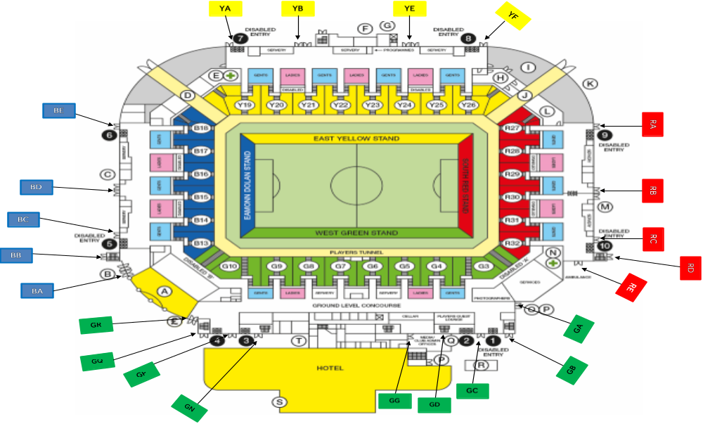
 | READING FOOTBALL CLUB STADIUM - READING FOOTBALL CLUB
 | ESCAPE AND SEATING CAPACITY
Reading Football Club Stadium Escape Network Calculation - Reviewed May 2020
Design Criteria: Time (8 minutes) x Flow Rate (66 people per minute) x width in metres
 |  | Vomitory | Escape | Vomitory Width (m) | Lower | Exit Volume | Final Exit Doors |  | Total
 |  |  | Capacity | Vomitory Width (m) | Vomitory (m) | of Vomitories |  |  | Seating
 | West Lower | G3 | 1478 | 1.5 | 1.3 | 11827.2 |  |  | 389 | 3101
 | West Lower | G4 | 1478 | 1.5 | 1.3 | 11827.2 | 1161 | 2.2m | 432
 | West Lower | G5 | 1478 | 1.5 | 1.3 | 11827.2 |  |  | 398
 | West Lower | G6 | 1478 | 1.5 | 1.3 | 11827.2 | 1161 | 2.2m | 351
 | West Lower | G7 | 1478 | 1.5 | 1.3 | 11827.2 |  |  | 351
 | West Lower | G8 | 1478 | 1.5 | 1.3 | 11827.2 | 1161 | 2.2m | 398
 | West Lower | G9 | 1478 | 1.5 | 1.3 | 11827.2 |  |  | 415
 | West Lower | G10 | 1478 | 1.5 | 1.3 | 11827.2 | 1161 | 2.2m | 367
 |  | total | 11827.2 |  |  |  | 4644 | section total
 |  | B12 | - | - | - |  |  |  | 144
 | Eamonn Dolan | B13 | 1346 | 1.25 | 1.3 | 9134.4 |  |  | 531 | 4970
 | Eamonn Dolan | B14 | 1452 | 1.45 | 1.3 | 9134.4 | 1214 | 2.3m | 800
 | Eamonn Dolan | B15 | 1452 | 1.45 | 1.3 | 9134.4 |  |  | 788
 | Eamonn Dolan | B16 | 1452 | 1.45 | 1.3 | 9134.4 | 3379 | 6.4m | 790
 | Eamonn Dolan | B17 | 1452 | 1.45 | 1.3 | 9134.4 |  |  | 798
 | Eamonn Dolan | B18 | 1980 | 2.45 | 1.3 | 9134.4 | 1267 | 2.4m | 1119
 |  | total | 9134.4 |  |  |  | 5860 | section total
 | East | Y19 | 1980 | 2.45 | 1.3 | 12672 |  |  | 1162 | 7170
 | East | Y20 | 1452 | 1.45 | 1.3 | 12672 | 1409 | 2.67m | 837
 | East | Y21 | 1452 | 1.45 | 1.3 | 12672 | 1409 | 2.67m | 828
 | East | Y22 | 1452 | 1.45 | 1.3 | 12672 | 1409 | 2.67m | 821
 | East | Y23 | 1452 | 1.45 | 1.3 | 12672 | 1409 | 2.67m | 821
 | East | Y24 | 1452 | 1.45 | 1.3 | 12672 | 1409 | 2.67m | 801
 | East | Y25 | 1452 | 1.45 | 1.3 | 12672 |  |  | 830
 | East | Y26 | 1980 | 2.45 | 1.3 | 12672 | 1409 | 2.67m | 1070
 |  | total | 12672 | Wheelchairs and helpers |  |  | 8454 | section total
 | South | R27 | 1980 | 2.45 | 1.3 | 9134.4 |  |  | 1075 | 4739
 | South | R28 | 1452 | 1.45 | 1.3 | 9134.4 | 1372 | 2.6m | 795
 | South | R29 | 1452 | 1.45 | 1.3 | 9134.4 |  |  | 623
 | South | R30 | 1452 | 1.45 | 1.3 | 9134.4 | 3379 | 6.4m | 821
 | South | R31 | 1452 | 1.45 | 1.3 | 9134.4 | 1161 | 2.2m | 798
 | South | R32 | 1346 | 1.25 | 1.3 | 9134.4 | 897 | 1.7m | 627
 |  | total | 9134.4 |  |  |  | 6809 | section total
 | Total Vomitories |  |  |  |  | 42768 | 25767 | ground level total | 20080 | 19980
 | West Upper | GU1 | 713 | 1.35m |  | Stair 1 | 1108 | (2.1m) | 315 | 3310
 | West Upper | GU2 | 713 | 1.35m |  |  |  |  | 247
 | West Upper | GU3 | 713 | 1.35m |  | Stair 2 | 1056 | (2.0m) | 352
 | West Upper | GU4 | 713 | 1.35m |  | Stair 3 | 1056 | (2.0m) | 351
 | West Upper | GU5 | 713 | 1.35m |  |  |  |  | 410
 | West Upper | GU6 | 713 | 1.35m |  | Stair 5 | 1425 | (2.7m) | hospitality
 | West Upper | GU7 | 713 | 1.35m |  | Stair 6 | 1056 | (2.0m) | hospitality
 | West Upper | GU8 | 713 | 1.35m |  |  |  |  | 358
 | West Upper | GU9 | 713 | 1.35m |  | Stair 7 | 1056 | (2.0m) | 338
 | West Upper | GU10 | 713 | 1.35m |  | Stair 8 | 1056 | (2.0m) | 366
 | West Upper | GU11 | 713 | 1.35m |  |  |  |  | 252
 | West Upper | GU12 | 713 | 1.35m |  | Stair 9 | 1108 | (2.1m) | 321
 |  |  | 8556 |  |  | 9152 | 8921 | upper level total
 | Hospitality | Suites | 1-28 |  |  |  | Stairs 1-9 |  | 292 | 1030
 | Hospitality | Royals |  |  |  |  | Stairs 1-9 |  | 48
 | Hospitality | Premier | SW Corner |  |  |  | Stairs 1-9 |  | 189
 | Hospitality | Club 106 | NW Corner |  |  |  | Stairs 1-9 |  | 187
 | Hospitality | GU5 |  |  |  |  | Stairs 1-9 |  | 157
 | Hospitality | GU6 |  |  |  |  | Stairs 1-9 |  | 157
 |  |  | Total Emergency Escape |  |  | 51920 |  |  | 4340 | 4340
 | Media / Medical / PA / Control Room / Camera Gantry / Observation Room |  |  |  |  |  |  |  | 127
 | Total Escape Width Bowl plus West Upper |  |  |  |  |  | 34688 |  | 24447 | 24320
 |  |  |  |  |  |  | lowest value taken for each section
 | Escape width exceeds seating by |  |  |  |  |  | 10241

Reading Football Club Stadium Entry Network Calculation - Reviewed June 2023
Design Criteria: Flow Rate (660 people) x number of turnstiles

 | Turnstiles | Accessible entries | Other entries | Entry capacity (not including accessible entries
West Lower | 5 | 1 | 0 | 3300
Eammon Dolan | 8 | 2 | 0 | 5280
East | 12 | 2 | 0 | 7920
South | 10 | 2 | 0 | 6600
West Upper | 6 | 1 | 0 | 3960
Hospitality | 0 | 0 | 3 | 1980

