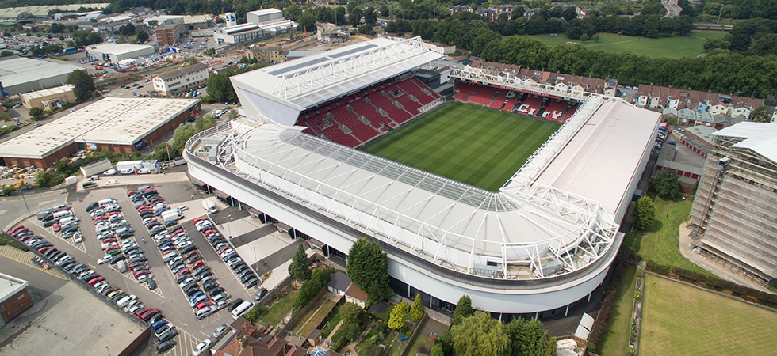

Stadium Operations Manual
43 – ALCOHOL MANAGEMENT POLICY

Audit & Review
The content and effectiveness of the policy, arrangements and guidance will be reviewed and revised as often as is necessary and as a minimum standard annually with any changes communicated as appropriate.
This and all other subsidiary policies and contingencies shall be subject to review on the basis of lessons learned following major events at Ashton Gate Stadium in addition to periodic reviews.
Safety reports will be provided to the Executive Management team post all major events.
Version control
Document Title: | Alcohol Management Policy
Document Owner: | Mark Kelly
Reference: | SOM 43

Document review
Last reviewed | Position
13/1/2025 | New Policy

Version history
Version | Date Released | Originator | Authorised | Comments
0.1 | 13/1/2025 | D Storr | D Storr | New Policy
0.2 | 15/1/2025 | D Storr | D Storr | Policy revised

Distribution list of authorised printed copies
Organisation | Position
Safety Advisory Group | Safety Advisory Group Members
Ashton Gate Ltd – Mark Kelly | CEO
Ashton Gate Ltd – Ross Wormald | Stadium Director
Ashton Gate Control Room | Safety Officers

- Contents

- Audit & Review
- Contents
- Purpose
- Scope & Objectives
- Policy Statement
- Alcohol Management Policy
- Linked Documents

Purpose
This policy supplements the Health and Safety Policy, Event Safety Policy, Safeguarding Policy and all other aspects of Venue Operations Manual of Ashton Gate Limited.
There are a number of Statutory Provisions which have relevance to the operation of this policy. The main examples are:
- Health and Safety at Work Act 1974;
- Licensing Act 2003;
- Safety of Sports Ground Act 1975;
- Regulatory Reform (Fire Safety) Order 2005;
- Equalities Act 2010
- GDPR 2018
- Sporting Events (Control of Alcohol) Act 1985

Scope & Objectives
Ashton Gate Limited is responsible for the management of The Stadium, Ashton Gate, Bristol. Ashton Gate Limited seeks to ensure that all events taking place at the venue are conducted in a manner that places safety including event safety as far as is practicable, above all other considerations. Ashton Gate Limited employs staff and external contractors to manage its facilities and also hires their services to event promoters and hosts.
Key Contractors working in partnership with AGL are Alert Systems (Access Control, CCTV and Intruder Detection), ADT (Fire Systems), Lancer Scott (Building Alterations), and Diamond Fire (Fire fighting equipment)
AGL’s responsibilities for event safety are set out in the Premises Licences and Safety Certificate it holds, copies of which are held in the Event Control Room. In addition it has general duties towards visitors in common law and under legislation. This policy seeks to ensure that these obligations and Ashton Gate Limited’s objectives for event safety are met.
The Event Safety Policy has been adopted by the Board of Ashton Gate Limited as a supplementary statement of intent regarding event safety.
This Policy will be shared with all employees and will be made available for reference within The Stadium premises.

Policy Statement
This policy is intended to ensure that where alcohol is sold on the premises all precautions are taken to prevent harm to children or vulnerable adults and Ashton Gate Limited abides by the relevant legislation concerned. Alcohol is permitted to be sold on the footprint of the stadium which includes areas surrounding the building such as car parks and pedestrian zones. All of these areas are referenced within the Premises Licence. Ashton Gate Limited, Bristol City FC and Bristol Bears Rugby will ensure that alcohol sold on the premises is consumed responsibly and appropriate action is taken against those who fail to comply with the ground regulations.

Alcohol Management Policy

Premises Licence, Safety Certificate and Restrictions
The Premises Licence for Ashton Gate is issued by Bristol City Council number 18/03907/PREM.

The last Safety Certificate was issued to Ashton Gate on 25th July 2023

Both the Premises Licence and Safety Certificate make specific references to the sale and consumption of alcohol at Ashtin Gate Stadium. For ease of reference, Alcohol may be sold from 1000hrs on any day of the week including Saturday and Sunday.

The permitted hours vary for sale depending on which part of the stadium is in use and what type of sport or event is in operation. Again, for ease of reference, permitted hours are 1000hrs to 2300hrs outside the stadium within the footprint on Rugby match days and 1000hrs to 2230hrs outside the stadium within the footprint on other sports days.
For private events within bars and lounges the sale of alcohol is from 1000hrs to 0200hrs Monday to Sunday
For other events within bars and lounges the sale of alcohol is permitted from 1000hrs to 0100hrs Monday to Sunday
The above includes concourses within the stadium.

The opening hours of the premises in licenced areas is from 0900hrs to 0230hrs Monday to Sunday

Sporting Events (Control of Alcohol) Act 1985

The above act applies to the consumption of alcohol in view of the playing surface at a designated sporting event, entering a stadium during a designated sporting event whilst drunk, as well as drinking whilst travelling to a designated sporting event in a vehicle capable of carrying more than 8 passengers.
It does not apply to Rugby games as these are not classed as designated sporting events. It does not apply to Women’s Football, although drinking alcohol in view of the pitch is governed by the competition rules and whilst no criminal offence would be committed, a football club may receive sanctions from the governing body.

Note: From 1st January 2025 to the end of the season (2024/2025), the competition rules will be relaxed at Ashton Gate Stadium for Bristol City Women’s football as part of a pilot scheme to allow drinking alcohol in view of the pitch whilst the game is in progress.

Licensing Objectives Compliance

The club’s strategy aligns with the four primary licensing objectives:
- Prevention of Crime and Disorder
- Public Safety
- Prevention of Public Nuisance
- Protection of Children from Harm

Alcohol sales points
The sale of alcohol is permitted from Concessions outside the ground but within the footprint, from concessions within the ground, from bars within the ground and from ‘Major Toms’ within the stands. The maximum number of mobile vendors (external concessions and Major Toms) is 24 – Internal bars and concessions do not form part of this number.
Licensed Door Supervisors
Events of less than 500 the event shall be risk assessed and if appropriate and Door Supervisors shall be employed accordingly. Events, including sporting events where the number of spectators is more than 500, the event shall be risk assessed and SIA Door Supervisors increased accordingly. A register will be kept of Door Supervisors on duty for each event.
Additional Training – Proof of age
Ashton Gate will ensure that staff employed in concessions are trained in accordance with the ‘Challenge 25’ protocols and may be required to ask for proof of ID for anyone purchasing alcohol. Valid forms of ID: Passport, driving licence, or PASS-accredited identification. As part of the Stadium ongoing customer service, mystery shoppers will be employed to check if the Challenge 25 and ‘Ask Angela’ protocols are being followed.

A Challenge 25 policy will be strictly enforced. Stewards and Security are to be briefed to actively challenge those that look Under 25 and confirm that they have the appropriate age identification as detailed above. CCTV will be monitored in all areas from the control room and staff will be directed to individuals or groups that have been highlighted.

First Aid Provision

For events with over 100 attendees, a risk assessment shall be completed to establish the need for trained/qualified first aid staff. Sporting events such as Football and Rugby shall have a separate medical plan agreed by the Safety Advisory Group and will include the agreed number of staff for the event relevant to the risk level. For games of over 2,000 a Crowd Doctor will be present and for games with over 5,000 an Ambulance Commander from SWAST (South West Ambulance NHS Trust) will be present in the Stadium Control Room. All first aid staff, concession staff and stewards have had briefings and training with regard to ‘Ask Angela’, a method used to raise awareness if someone needs assistance due to domestic violence or abuse.
Sale and Consumption of alcohol
Alcohol sold from concessions externally will be decanted into clear plastics, cans and plastic wine bottles must be retained in the concession. Plastic drinks bottles will have the seal broken and then replaced at the point of sale to ensure the pressure within the bottle is released and cannot be thrown to cause an injury. Staff will be briefed on the quantity of drinks permitted to be sold to individual people to prevent excessive drinking.
During Rugby games, drinks may be purchased for consumption in the stands and can be purchased in larger vessels to reduce the amount of times spectators need to return to the concessions. During designated Football games, alcohol cannot be consumed in view of the pitch and therefore concourses may become crowded pre-match and during half time.
Stewards and CCTV operators are trained to recognised over-crowding or crowd distress and to report this immediately to the Safety Officer. Each game is taken on it’s own merits and therefore it should be noted that the capacity of each concourse is as follows; West Lower – 3,000, West Upper – 1,100, South – 2,800, Dolman – 2,500. Depending on the capacity of the stand, the concourses have the ability to hold most spectators and therefore the queue systems at concessions and toilets my be the pinch points and will require monitoring.
Note; The relaxation of consumption during Bristol City Women’s games

Pilot Scheme – Bristol City Women (Season 2024-2025)
During this pilot, all stewards will be briefed concerning consumption of alcohol in view of the pitch. All stewards should pay particular attention to families where parents are apparently consuming alcohol and any concerns should be raised immediately with the control room who will then inform the Senior Safeguarding Officer.
Instances of disorder or where spectators disturb other spectators as a result of drinking alcohol shall also be recorded and reported.
There may be times when, for example, due to religious reasons, stewards are approached by spectators with a view to re-locating them in areas where alcohol is not being consumed. These instances will be monitored by the Safety Officer and if appropriate- a designated area may be allocated which can be ‘alcohol free’. This will be a process to be used as best practice or good customer service if the need arises.
A de-brief will be held after each game to record any instances to report back and a formal report shall be completed for the information of the Safety Advisor Group at the end of the season/pilot.
Data collection for specific sales types, quantity etc will all form part of the data collection for Ashton Gate purposes but this will also be available to the WPLL should it be required. Data collection will also come from complaints, instances of intoxication, and feedback from stewards, CCTV and spectators.
Promotion of Responsible Drinking
Signage and Messaging: Digital screens will promote responsible drinking messages. This will be also included in pre match and during match communication, via website and large screens within the stadium.

Alcohol-Free Options: Non-alcoholic drinks will be available.

A Safeguarding team will be available for all games, they will have the ability to move families and children to other blocks in the stadium if any fan does not want to be near persons drinking alcohol in the stand. This will be done through the control room in the first instance.

If any individual(s) show signs of excessive consumption, they will be refused further service, and this noted in the control room log. If applicable safeguarding or medical teams will be deployed to assist this individual.

SIA Response staff will always be deployed in the concourses and be available to deal with instances of intoxication or disorder. They are deployed in pairs and at least one will hold a radio to be contactable through the control room. Response staff will also monitor spectators for large purchases of alcohol to pre-empt any issues later.

Potable water is available at all concessions free of charge. Water re-fill stations are available around the stadium in the concourses.

Staff members involved in this pilot are as follows;
Gavin Marshall CEO
Ross Wormald Stadium Director
David Storr/Eddie Liddiard Safety Officers
Emma Joliffe/Tom Hambridge Team Operations Managers
Romaney Pinnock Team Manager
Lisa Rees Head of Finance
Dave Gorwill Head of Concessions
Annabelle Coffin Events Manager
Dave Barton/Sheridan Robins Head of Media
Shehan Jayasinghe Head of Ticketing

Linked Documents
- Evacuation Plan
- Capacity Calculations
- Fire Risk Management Plan
- Guide to Public Safety Planning and Operations
- Guide to Spectator Safety (Green Guide)
- Health and Safety at Work Policy
- Induction & Training Records
- Medical Plan
- Pre-Event Action Plans
- Generic Risk Assessments
- Event Specific Risk Assessments
- Briefing Documents
- Safeguarding Policy
- Staff Handbook
- Standard Operating Procedures
- Contingency Plans
- Stewarding and Crowd Management Plan
- Premises Licence

